**Updated: 13th June 2024**

**DRESS CODE**

The Fraser Park Primary School dress code will be consistent with the policy of the Department for Education, as expressed in the Education Act. No student should be educationally disadvantaged for not wearing the school uniform. The school recognises the diversity of its community and respects the cultural and religious beliefs of its members.

Wearing of uniforms reduces peer pressure and encourages appropriate clothing for school activities. The school uniform should be worn with pride and in an appropriate manner.

1. Uniform

Fraser Park logo t-shirt and logo jumper are stocked onsite and are available for sale from the front office.

The uniform is based on the school colours of black, yellow and green and is itemised below.

* Plain black pants or track pants or plain black skorts, skirts or shorts.
* Plain grey pants or track pants or plain grey skorts, skirts or shorts.
* Bottle green or yellow short or long sleeve polo shirt.
* Plain Black leggings.
* Plain Black jumper.
* Summer school dress, green check.
* Students are required to wear hats during terms 1,3 and 4 on days when the UV rating is above 3. School hats are available for sale from the front office. Every child will receive one free hat when starting at Fraser Park Primary School.
* Year 6 students: To encourage a greater sense of identity and responsibility, year 6 students may also wear a specially designed ‘seniors’ t-shirt and jumper.

Additionally:

* If parents choose to purchase polos or jumpers without logo, logos are available for $8, order through front office staff.
* Sandals may be worn in summer (thongs are considered dangerous and are not permitted), whilst the wearing of closed in shoes is encouraged at all times.
* Jewellery can frequently be a health and safety risk and is therefore not permitted, other than sleeper or stud earrings, watches, or medically required identification.
* The wearing of brand names on clothing is not permitted including football colours.
* SAPSASA State/ National team commemorative tops may only be worn by students for 1 week (5 days) following competition.
* Hair that is longer than shoulder length should be tied back for health and safety reasons.

**Dress Code**

**Updated 13th June 2024**

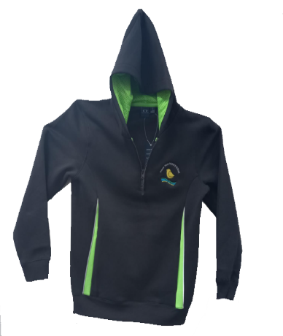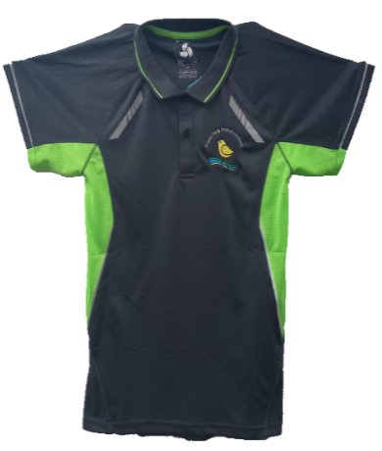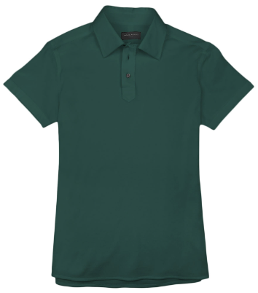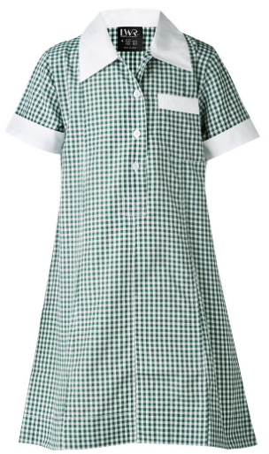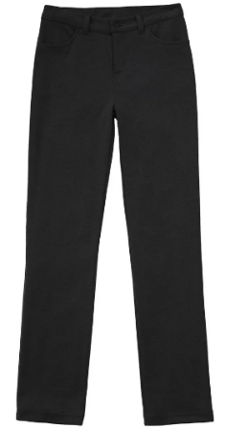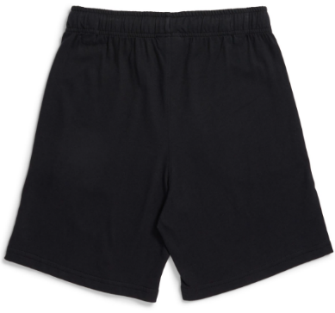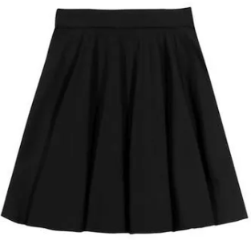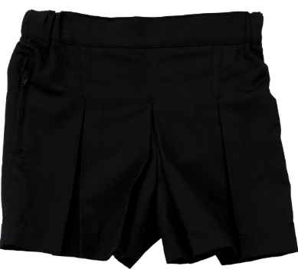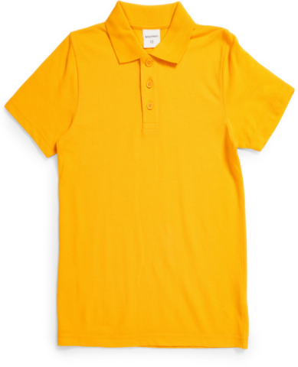

**Green Checkered Dress**

**School Jumper**

**School Polo Shirt**

**Green Polo Shirt**

**Yellow Polo Shirt**

**Black Pants**

**Black Skirt**

**Black Skort**

**Black Shorts**